Página principal

Menu Administrar estudiantes -> Listar estudiantes

Menu Administrar estudiantes -> Crear estudiante

Al revisar nuevamente la lista, se puede ver que ha sido ingresado:

Menu Administrar estudiantes -> Actualizar estudiante

Se presiona el icono de lápiz

Se actualizan los datos

Al revisar nuevamente la lista, se puede ver que ha sido actualizado:

Menu Administrar estudiantes -> Eliminar estudiante

Se presiona sobre el icono de eliminar.

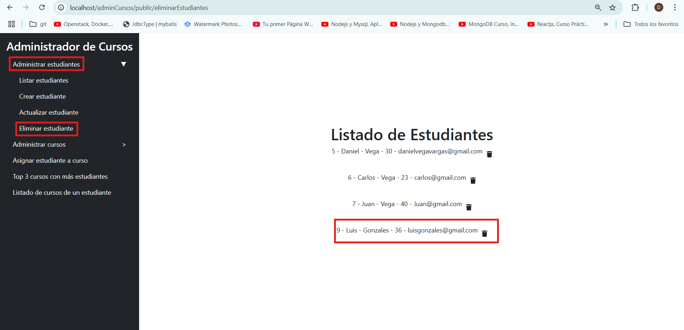

Al listar nuevamente ya se no encuentra al estudiante

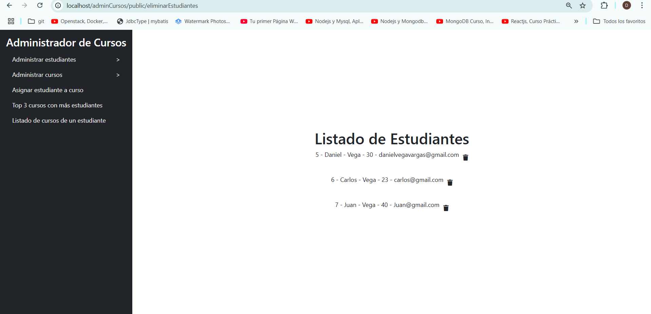

Menu Administrar cursos -> Listar cursos

Menu Administrar cursos -> Crear curso

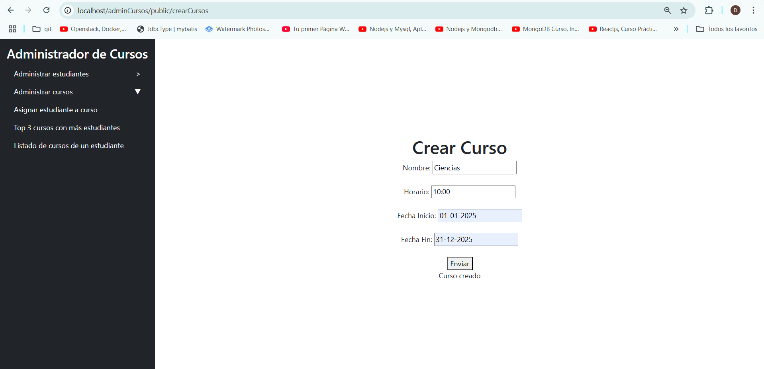

Al revisar nuevamente la lista, se puede ver que ha sido ingresado:

Menu Administrar cursos -> Actualizar curso

Se presiona el icono de lápiz

Se actualizan los datos

Al revisar nuevamente la lista, se puede ver que ha sido actualizado:

Menu Administrar cursos -> Eliminar curso

Se presiona sobre el icono de eliminar.

Al listar nuevamente ya se no encuentra al estudiante

Menu Asignar estudiante a curso

Menu Top 3 cursos con mas estudiantes

Menu Listado de cursos de un estudiante

Tecnologías utilizadas:

Base de datos: MySQL

Aplicación: Laravel – PHP (BACK-END)

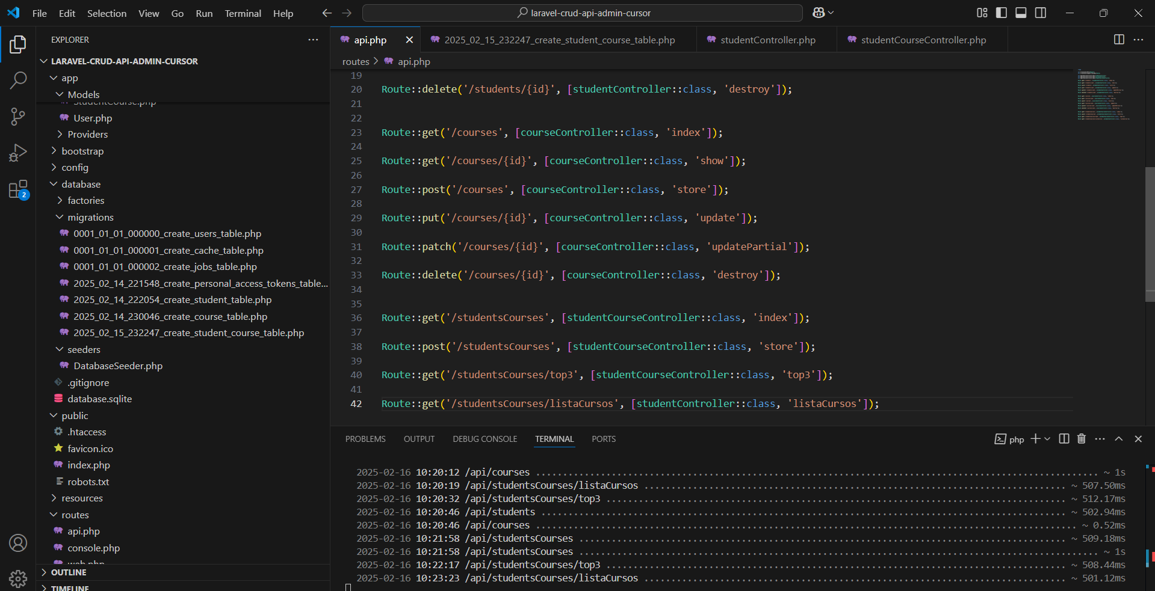

Larvel – Blade Consumiendo la API(FRON-END)

Boostrap.js

POSTMAN (Test)

